To log into HighQ for the first time:

You will receive an invitation from Viktoria, that looks like this:

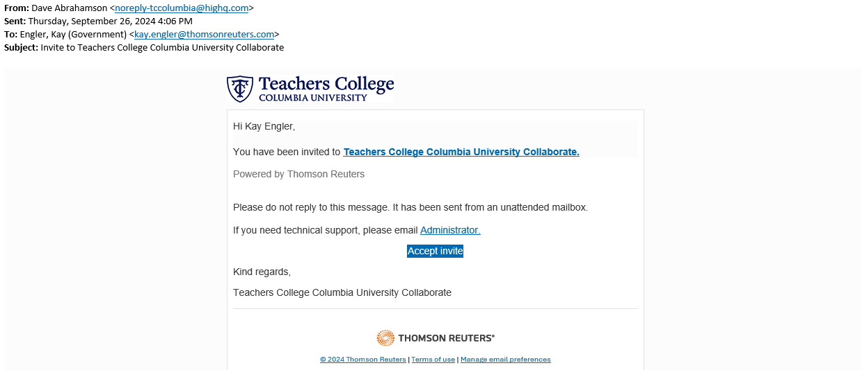

Click on “Accept invite”.

And you will be sent to this screen:

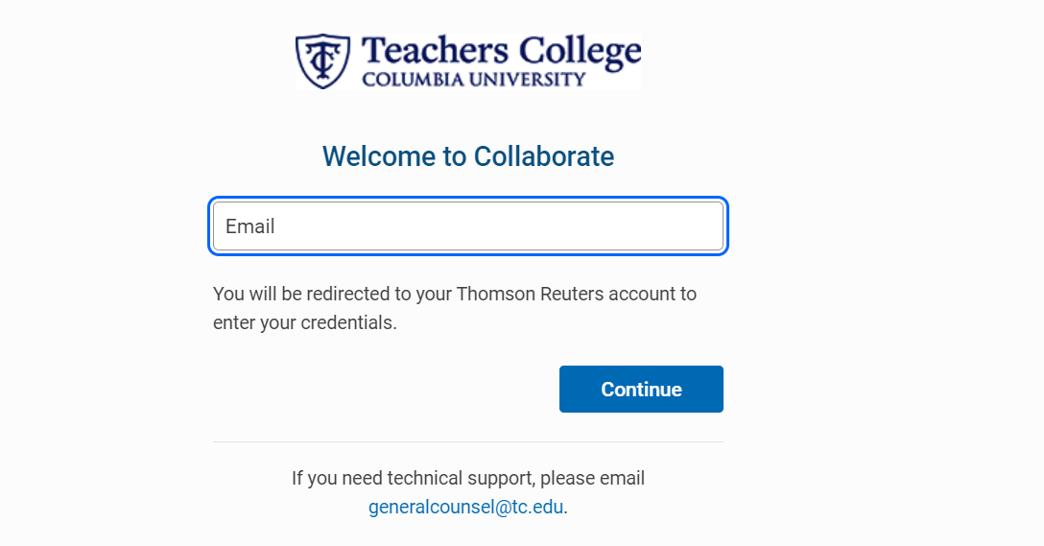

Enter your Teacher’s College email address and click “Continue”.

Then you will see your normal Teacher's College Single-Sign On screen. Enter in your credentials and you will then gain access to your HighQ site.

After your initial HighQ login, you can use this link to gain access to your HighQ site:

<https://tc.highq.com/tccolumbia>

I would suggest you Bookmark this link.

You will then see the HighQ Login screen:



Enter your Teacher’s College email address and click “Continue”.

Then you will see your normal Teacher's College Single-Sign On screen. Enter in your credentials and you will then gain access to your HighQ site.

This is your Teacher’s College HighQ Homepage:

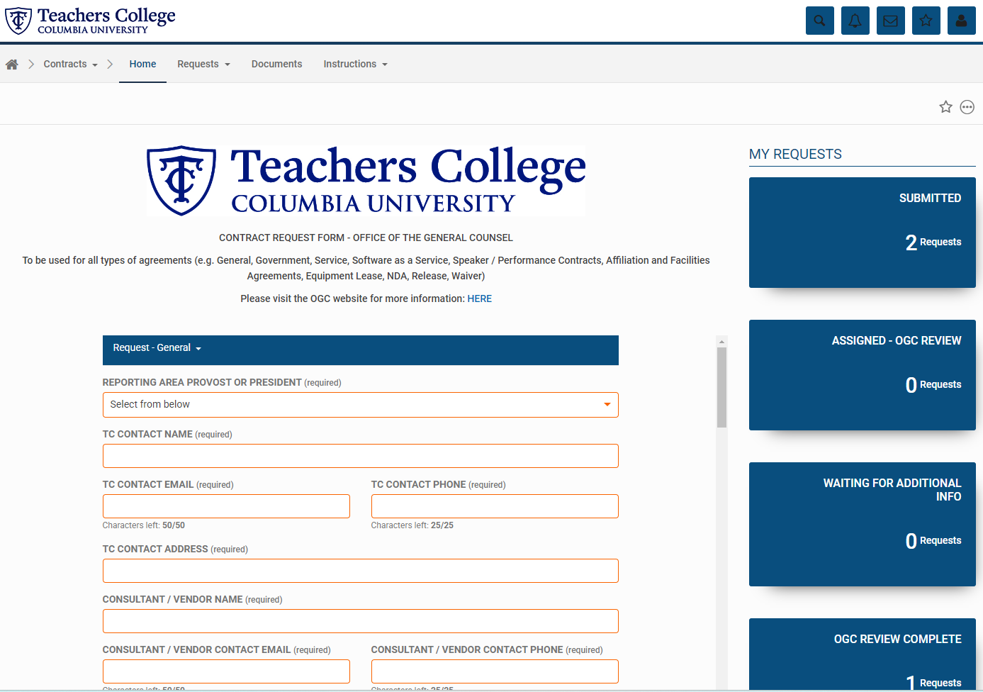

From here you can either submit a new contract into the request intake form by filling out the fields of the form and clicking on “Submit” at the end of the form. Or see the status of any previous forms that you have submitted by clicking on one of the KPI cards along the left side of the screen. The KPI cards are there to show where your former submissions are in the approval process. Or to view all your formerly submitted requests you can click on the Requests dropdown in the taskbar and then click “Requestor Status View”:



If you need to add/edit something from one of your former submissions, click on the circle with the three dots to the left of the “Request Name”:

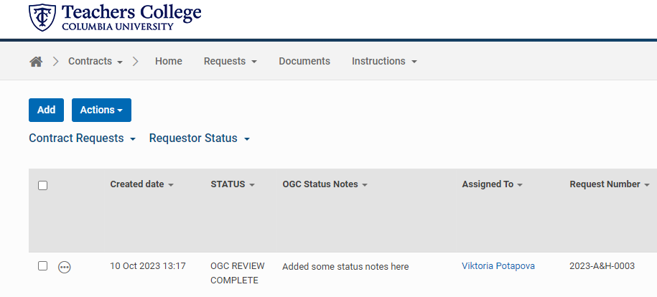

That will give you more options to your request:

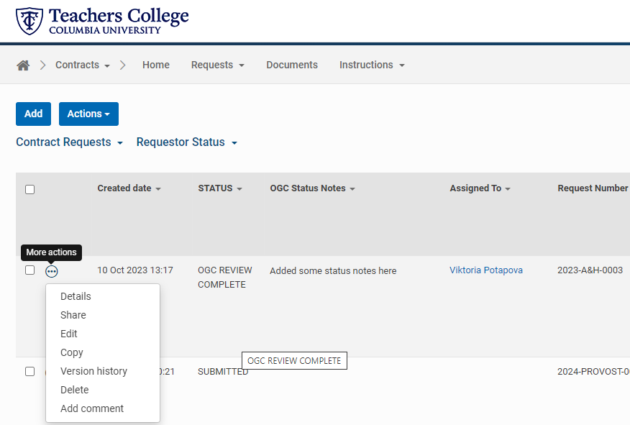

Click on the “Edit” option.

After clicking on the “Edit”, this is what you will see:

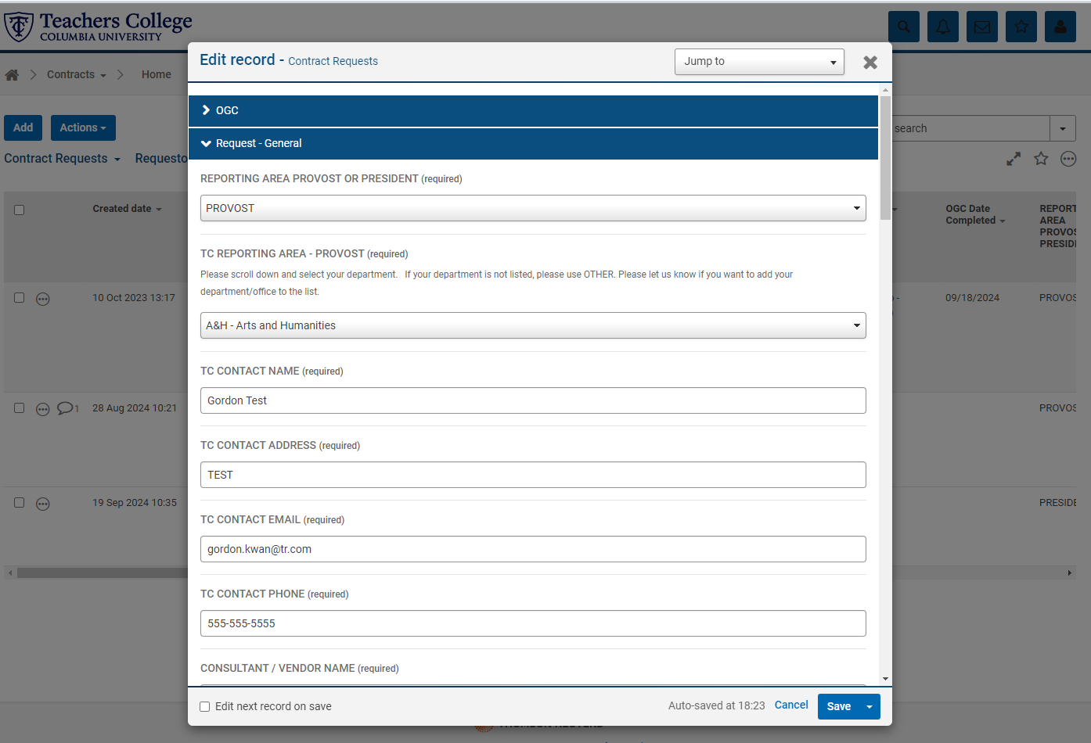

From here you can scroll down to the field you want to edit or add to. When you’re finished in the bottom right click on “Save”.

Here are the instructions, if you want to send a comment to someone inside of HighQ:

Click on the circle with the three dots and then on “Add comment”.



In the Comment Box, enter the “@” symbol and the person’s name. Click on the person’s name when it appears in the gray box below:

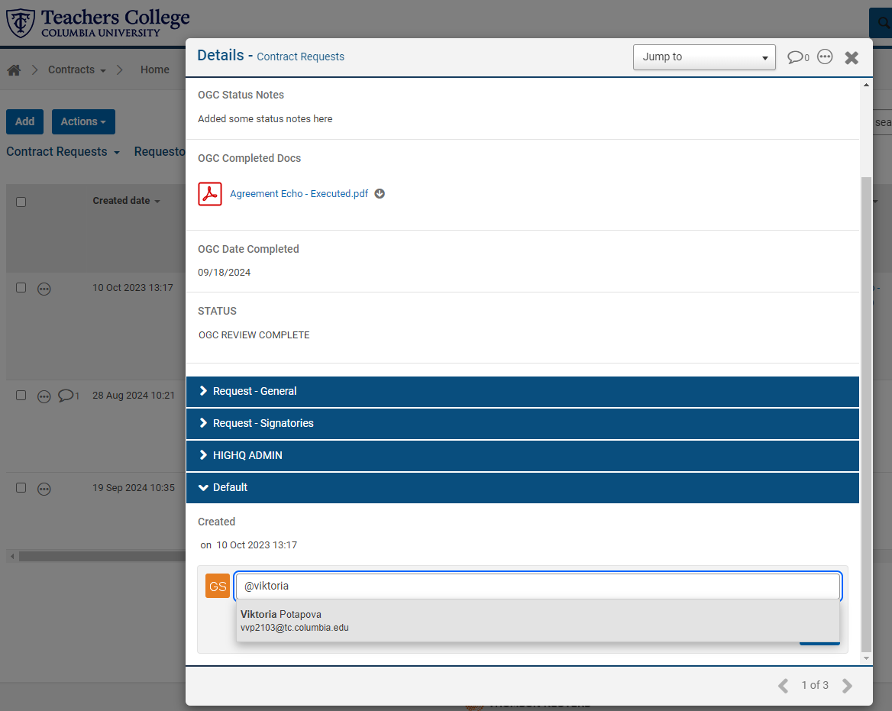

Add your comment and click “Post”.

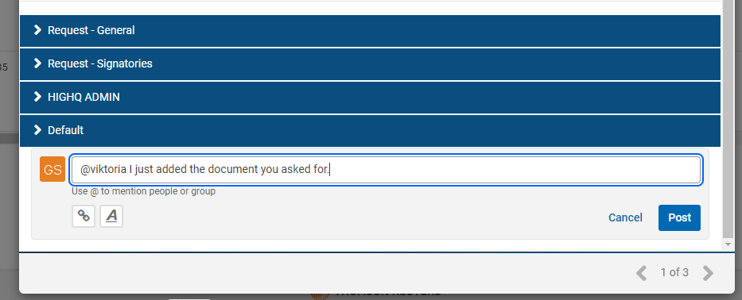

How to Edit your User Profile:

In the upper right corner of the Homepage, click on the Avatar icon and then “My Profile”:

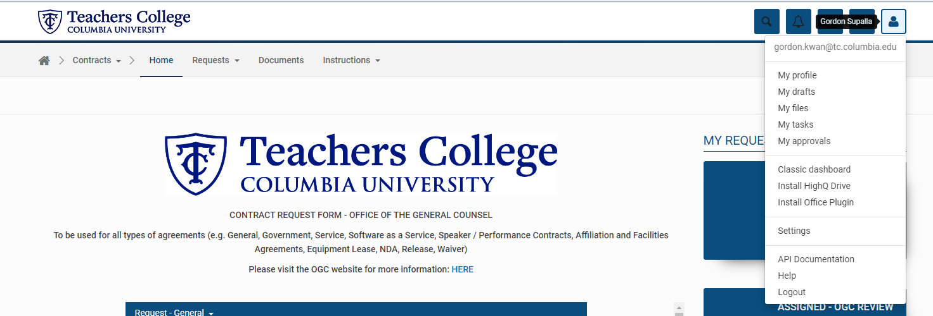

Click on “Edit Profile”:

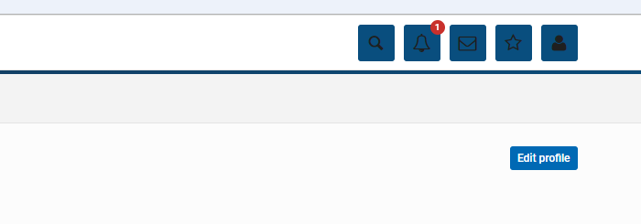Enter information in the fields that you want and click “Save”: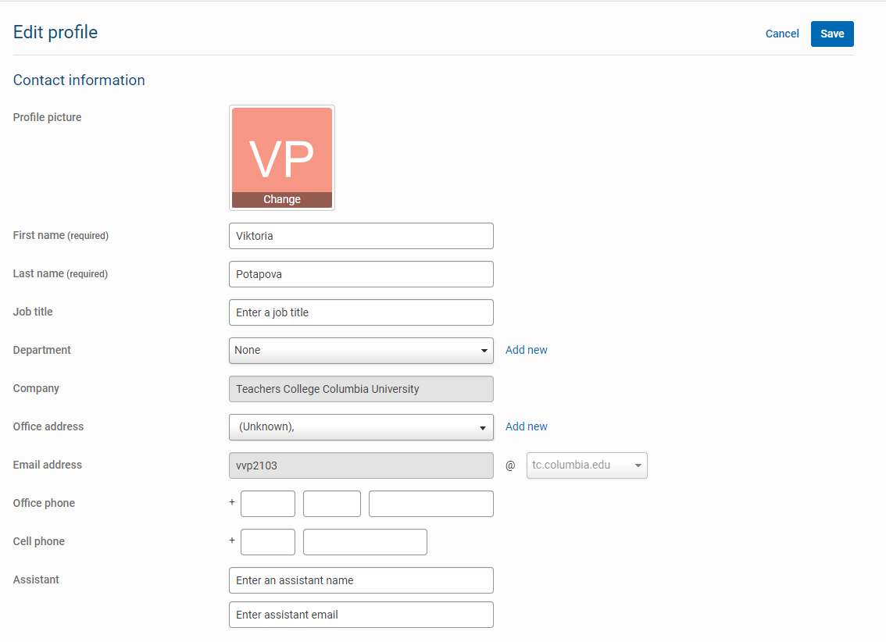



How to access the HighQ Help and Support website:

In the upper right corner of the Homepage, click on the Avatar icon and then “Help”:





HighQ Help and Support:

