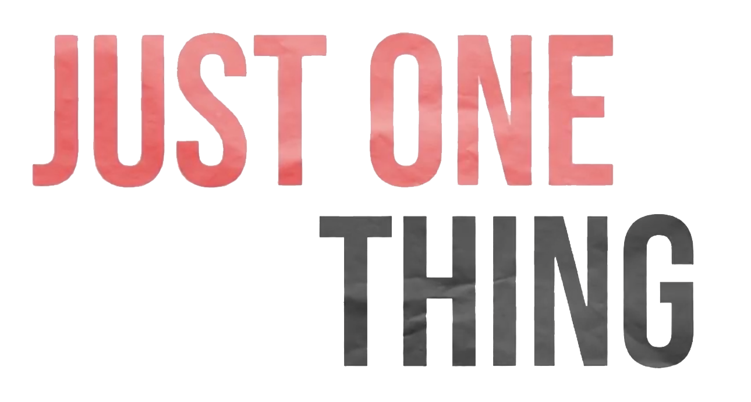
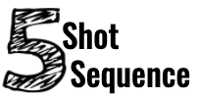

Composing a video has grammar and shape just as a written paper. As an exercise to get started in communicating your ideas through videos is to try a five-shot sequence challenge.
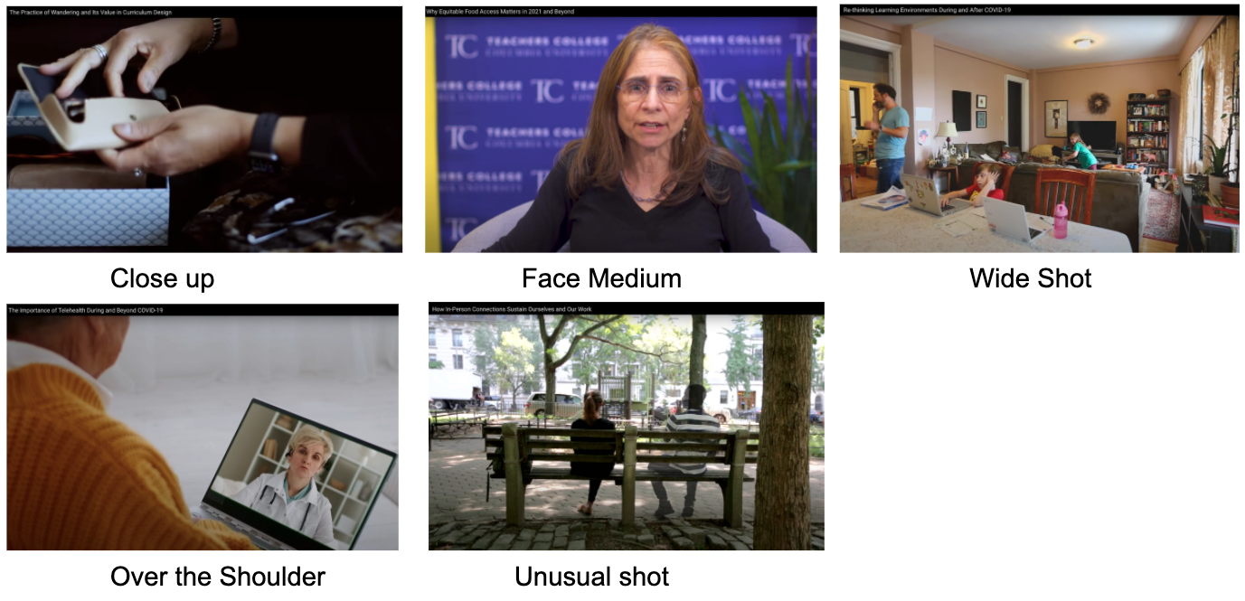
The Close up (The What): This shot is usually of someone's hands in contact with the topic you would like to address. Think of this as helping your audience focus on your main thesis.

Face Medium (The Who): This shot helps us understand who is involved with the action that was seen in the former shot.

Wide Shot (The Where): Here you show your audience where the subject is, often showing the surrounding area with your subject clearly in the shot.

Over the Shoulder (The How): This shot is dedicated to inviting your audience into the world of your subject, they see as an onlooker how that subject is involved in the topic.

Unusual Shot: This shot is often used to help you include any additional information you would like to share with your audience. You can do a Personal Point of View (POV) or stand up high or get down low with the camera to help express a mood for your topic.

Watch one of the Just One Thing videos and take notes on the shots you notice:

Close up | Medium | Wide | Over the Shoulder | Other

Now it is your turn to answer these simple but important questions:

What are you talking about?

Who is involved?

Where are they situated?

How are they doing the action?

What else do you need to share?

Before you head out to take on this challenge make a visual or text-based storyboard of what you would like to capture for this project.

 | Close up (What) | Medium Face (Who)
Wide Shot (Where) | Over the Shoulder (How) | Unusual shot (and Also)

Tips and Tricks:
- Shots generally range anywhere from 5-30 seconds, it can really depend on your project but don’t be afraid to shoot for more time, you can always shorten the shot.
- Always have a backup. Shots may not end up how you want them--it is always great to have a backup idea to try before you get shooting.
- Record additional B-Roll audio of where you are shooting. You can simply do this by recording it on your phone, capturing the background sounds from where you recorded your topic.
- Make sure to review your shots quickly to see if you like the focus, lighting, and framing.

Notes:

